Annexe 1 : a) Trame de redaction pour les projets de recherche

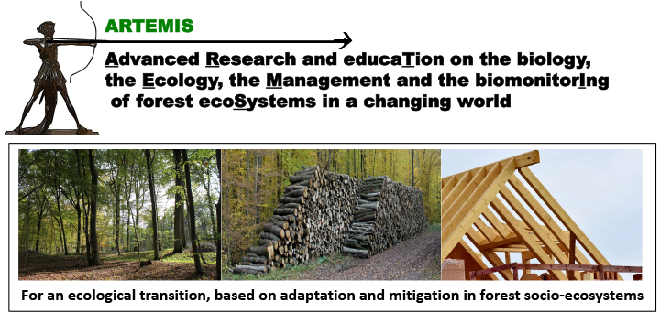 | Émergence du Programme Interdisciplinaire ARTEMIS  Appel ‘Graines d’Artemis’ (GA_2024)

Call for Proposals 2024
RESEARCH
SEED projects in research or translational research
Deadline October 31, 2023
Project Title:
Acronym:
Project Leader * (name and Research Unit):
Co-applicants (names and Research Unit):
ARTEMIS operational challenge (OC) concerned:
Other ARTEMIS OC(s) concerned:
Start and end dates of the project: | XX to XX 2024. or XX 2024 to XX 2025
Confidential reviewing: yes / no
* in the case of a project submitted by a non-permanent scientist a referent person has to be identified. This referent person will be in charge of performing the project and/or of its justification, in the case the project leader has to leave the lab before the end of the project.
Executive summary (1/2 page max.)
Research proposal (6 pages max.), including:
Context and background information (1 page max.)
Rationale for proposed research and specific objectives (1 page max.)
Description of proposed research (2 pages max.)
Scientific Information (including novelty of the project) Technical Information
Available Resources
GANTT Chart

Project positioning according to the different operational challenges (cf Annexe 2)

Research teams and management (1 page max.) including expertise of the PI’s to perform this work
Positioning in national and international networking (1/2 page max.)

Financial Information (1/2 page max. each). All costs should be indicated Tax Free.
Expense type | Euro
Functioning and Travel expenses
Subcontracting
Salaries (master students….)
Small equipment (<4000 Euros)
Requested or current matching funds (Agreenskills, ANR, PEPR, Région Grand-Est…)
Total
References
Please send your application in word format to ARTEMIS-PgI@inrae.fr and the name and address of five referees with no conflict of interest.

Annexe 1 : b) Trame de rédaction pour les projets de formation/education/SAPS*

Émergence du Programme Interdisciplinaire ARTEMIS

Appel ‘Graines d’Artemis’ (GA_2024)

Call for Proposals 2024 EDUCATION/FORMATION/SAPS
SEED projects in research or translational research

Deadline October 31, 2023
Project Title:
Acronym:
Project Leader ** (name and Research Unit):
Co-applicants (names and Research Unit):
ARTEMIS operational challenge (OC) concerned:
Other ARTEMIS OC(s) concerned:
Start and end dates of the project: | XX to XX 2024. or XX 2024 to XX 2025
*SAPs: science avec et pour la société= science with and for society
** in the case of a project submitted by a non-permanent scientist a referent person has to be identified. This referent person will be in charge of performing the project and/or of its justification, in the case the project leader has to leave the lab before the end of the project.
Executive summary (1/2 page max.)

Education/formation/SAPS proposal (6 pages max.), including:

Type of event | ☐ Summer school ☐ Formation ☐ Other
Scope of the event | ☐ local ☐ National ☐ International
Expected date | ……
Expected duration | …..
Place | …..
Expected number of participants | …..
Editing of a support of communication (article, book, chapter, website) | ☐ oui ☐ non
Context and background information (1 page max.)

Rationale for the proposal and specific objectives (1 page max.)

Description of the proposal including available resources and benefits for the ARTEMIS community and LUE education/formation/SAPS sector (2 pages max.)

Project positioning according to the different operational challenges (cf Annexe 2)

Project teams (1 page max.) including expertise of the PI’s to perform this work
Positioning in the LUE, Regional, and National networking (1/2 page max.)
Financial Information (1/2 page max. each). All costs should be indicated Tax Free.
Expense type | Euro
Functioning and Travel expenses
Subcontracting
Salaries (master students….)
Small equipment (<4000 Euros)
Requested or current matching funds (Agreenskills, ANR, PEPR, Région Grand-Est…)
Total
References
Please send your application in word format to ARTEMIS-PgI@inrae.fr and the name and address of five referees with no conflict of interest.

