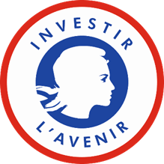
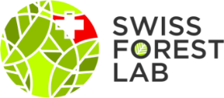
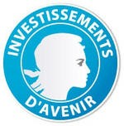

Laboratoire d’Excellence ARBRE
Recherches Avancées sur la Biologie de l’Arbre et les Ecosystèmes Forestiers

SwissForestLab
the Swiss forest network to promote excellence in forest ecosystem research

Call for Proposals 2022
Innovative research or outreach projects
<180.000€ for the common ARBRE-SwissForestLab proposals
Deadline: October 31, 2021
Title of the proposal:
Acronym:
Project Leader Labex ARBRE (name and Research Unit):
Project Leader SwissForestLab (name, Institution and Research Unit):
Co-applicants (names Institutions and Research Unit):
ARBRE work package:
Other ARBRE work package(s) concerned:

Main Research Topic(s) and Question(s) of the SwissForestLab concerned:
Start and end dates of the project: Confidential reviewing: yes / no

- Executive summary (1 page max.)

- Research proposal (10 pages max.)
- Context and background information (1 page max.)
- Rationale for the proposed research and specific objectives (1 page max.)
- Description of the proposed research (3 pages max.): Scientific Information (including novelty of the project), Technical Information, Available Resources, GANTT Chart…
- Contribution to the different Arbre work-packages (cf Annex 3) and Research Fields and Questions of the SwissForestLab (cf. Annex 4)
- Benefits for ARBRE and SwissForestLab (1 page max.): Anticipated scientific and socio-economic benefits; Stakeholder involvement/Facilitating knowledge translation to end-users
- Research teams (1 page max.) including competence of the PI’s to perform this work
- Management (Coordination, Data & Resource Sharing, Outreach) (1/2 page max.)
- Complementarity between the French and Swiss partners
- National and international networking
- Financial Information (1/2 page max. each). All costs should be indicated Tax Free. Salaries; Small equipment (<4000 Euros); Travel expenses; Requested or current supplemental funding; Others.
Do not forget to join the funding plan (Excel Document to be downloaded from the Labex ARBRE website)

- References

Please send your application in word format to labex-arbre-nancy@inrae.fr with the name and address of five foreign referees with no conflict of interest.

